SOME REMINDERS:

The photographs in the table were placed inside a shape. Follow these steps in replacing the photo with the right photo of the plant:
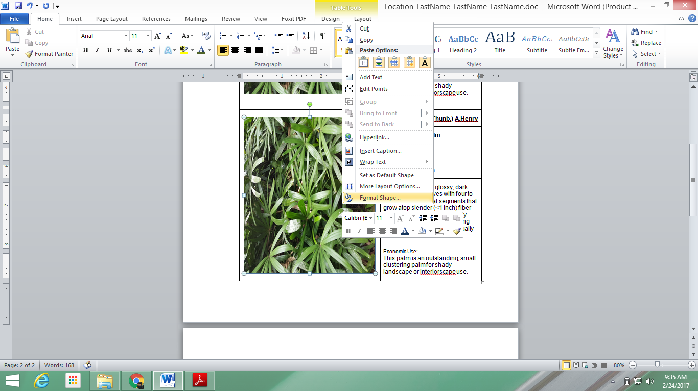
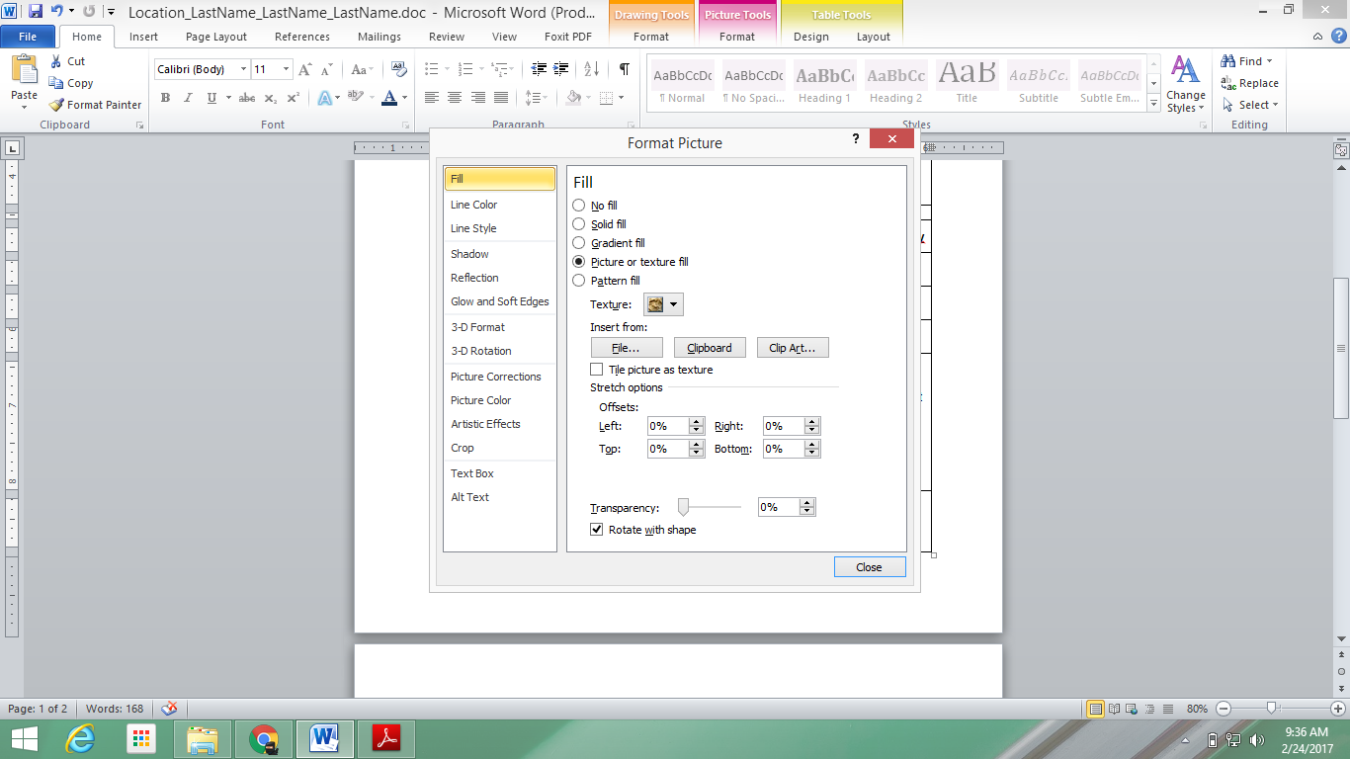
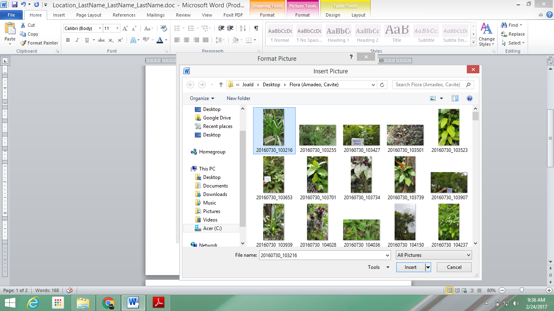

Limit to two plants in one page. In writing the scientific name, be sure to italicize the first two names and include the name of the author after the two names.

Include a very short description of the plant and its economic use.

DO NOT ADJUST THE SIZE OF THE TABLE, its columns, rows and cells.

If you have any question, contact me at 0927 871 3010. Please include your name in the message. Happy writing!

